AHMEDABAD TO MUMBAI HIGH SPEED RAILWAY PROJECT

Project for the degree of

MSc (Integrated) AIML
Sem -6

by

RAVAL DAIVIK ALPESHBHAI
ROUTH ABHIJEET ASSIM

Under the guidance of
DR. AKASH SINGH Submitted to

 | 

Department of AIML/DS
School of Emerging Science & Technology
Gujarat University
- Front Cover (Pg no-1)
Index
- Index (Pg no-2)
- Introduction (Pg no 3-4)
- Abstract (Pg no 5)
- Objective (Pg no 6)
- Constraints (Pg no 7)
- Review of Literature (Pg no 8)
- Land Acquisition status (Pg no 9-10)
For bullet train project
- Overview of project (Pg no 11)
- Methodology (Pg no 12-19)
- File Structure (Pg no 20)
- Visual Output 1 (Pg no 21)
- Visual output data 1 (Pg no 22)
- Visual Output 2 (Pg no 23)
- Visual Output data 2 (Pg no 24)
- Conclusion (Pg no 25-26)
- References (Pg no 27)

INTRODUCTION
- The Ahmedabad-Mumbai High-Speed Railway (HSR) Project, also known as the Mumbai-Ahmedabad Bullet Train, is India’s first high-speed rail corridor. It is being developed with technical and financial assistance from Japan, utilizing the advanced Shinkansen (bullet train) technology.
- Key Features of the Project:
- Route: Ahmedabad (Gujarat) to Mumbai (Maharashtra)
- Total Distance: 508.17 km
- Number of Stations: 12 (Including Mumbai, Thane, Virar, Surat, Vadodara, and Ahmedabad)
- Top Speed: 320 km/h
- Expected Travel Time: 2 to 2.5 hours (compared to 6-7 hours by conventional trains)
- Technology Used: Japan's E5 Series Shinkansen technology
- Executing Agency: National High-Speed Rail Corporation Limited (NHSRCL)
- Funding: Approx. ₹1.1 lakh crore (80% financed by a

INTRODUCTION
Significance of the Project:
- Faster and Safer Travel: Significant reduction in travel time with world-class safety measures.
- Economic Growth: Boosts infrastructure, employment, and real estate development along the corridor.
- Technology Transfer: Enhancing India's railway capabilities with Japan’s advanced technology.
- Sustainability: Energy-efficient and environmentally friendly transportation system.
Current Status:
Initially targeted for completion by 2023, the project faced delays due to land acquisition issues and the COVID-19 pandemic. The revised completion timeline is projected around 2026-2027.
This high-speed railway will revolutionize transportation between Gujarat and Maharashtra, setting a precedent for future bullet train projects in India.

ABSTRACT
This study present a PERT and CPM model which approach to manage the construction. While addressing the key constraints of construction are its resource limitation while construction which are
- Raw material availability : Steel , sand and gravel , cement and concrete
- Energy resources : Electricity supply , fuel for construction
The model contains 12 different station which is long with approximately of 508 km. Thus to build the path various kind of materials are required which delay due to seasonal conditions like rain and fog a model has been carried out to show much days delay it will take to supply material and work will be started. Jupyter notebook software is used to analyze the result of this pert and cpm model.

The primary objectives of the Ahmedabad-Mumbai High-Speed Railway Project are:
OBJECTIVE
- Reduce Travel Time: Provide a fast and efficient mode of transport, reducing travel time between Ahmedabad and Mumbai from 6-7 hours to approximately 2-2.5 hours.
- Enhance Connectivity: Strengthen regional connectivity, fostering economic and social integration between Gujarat and Maharashtra.
- Promote Economic Growth: Drive infrastructure development, create employment opportunities, and boost real estate and commercial activities along the corridor.
- Introduce Advanced Rail Technology: Implement Japan’s cutting-edge Shinkansen technology, improving India’s railway system and operational efficiency.
- Ensure Safety and Comfort: Provide a world-class, safe, and comfortable travel experience with modern amenities and disaster-resilient design.

- Land Acquisition Issues: Delays due to resistance from local farmers and landowners, affecting project timelines.
CONSTRAINTS
- High Project Cost: The estimated cost of ₹1.1 lakh crore poses financial challenges and requires effective fund management.
- Environmental Concerns: Impact on wildlife and ecology, particularly in forested and coastal areas along the corridor.
- Technological Adaptation: Integrating Japanese Shinkansen technology into India’s railway infrastructure requires specialized training and adaptation.
- Regulatory and Legal Challenges: Compliance with multiple state and central government regulations prolongs approval processes.
- Construction Delays: The complexity of constructing tunnels, elevated tracks, and undersea sections presents engineering challenges.

Several studies and reports have examined high-speed rail projects worldwide, offering insights into their impact on economic growth, technological advancements, and transportation efficiency. Key findings include:
REVIEW OF LITERATURE
- Global Case Studies: Research on Japan’s Shinkansen, France’s TGV, and China’s high-speed rail network highlights improvements in regional connectivity and economic development.
- Economic Benefits: Studies suggest that high-speed rail boosts urbanization, enhances business productivity, and reduces reliance on air travel.
- Technological Implementation: Literature emphasizes the importance of technology transfer, skill development, and infrastructure adaptation when integrating foreign rail technologies.
- Challenges in Implementation: Reports highlight land acquisition difficulties, high construction costs, and regulatory challenges as common hurdles in high-speed rail projects.

Land Acquisition Status For Bullet Train Project

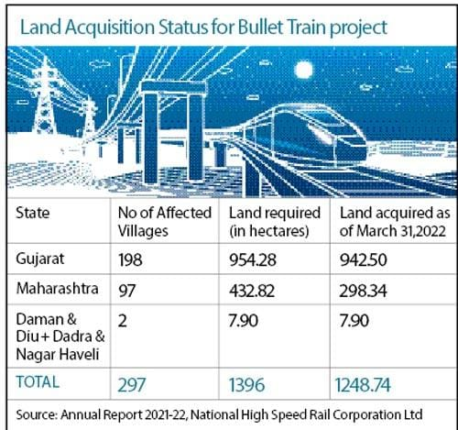
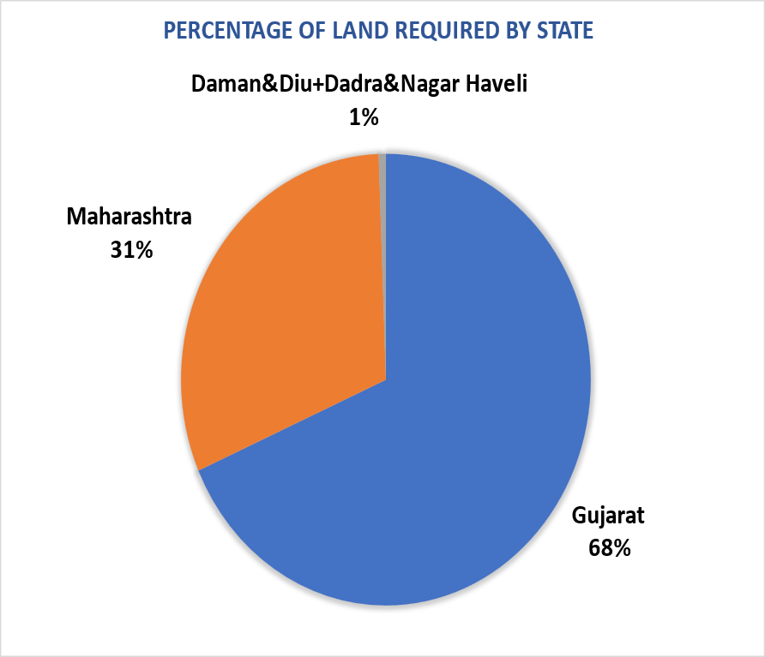

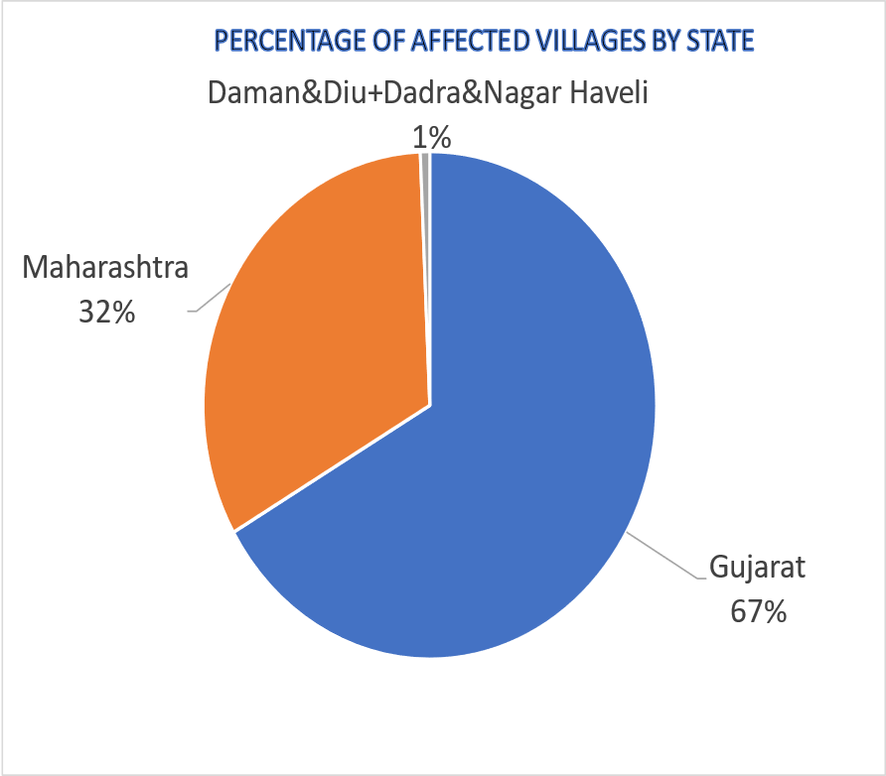
OVERVIEW OF PROJECT

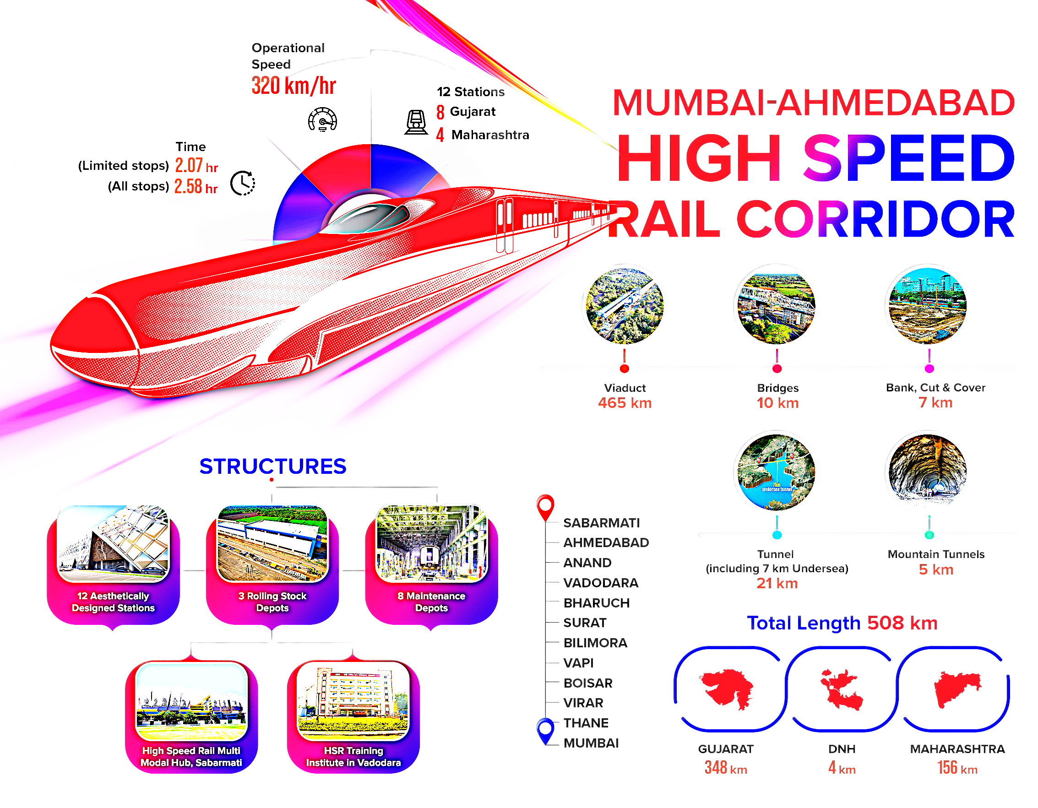
This code is an implementation of the PERT (Program Evaluation and Review Technique) and CPM (Critical Path Method) for project management, extended to incorporate resource constraints. The code follows a structured approach for project scheduling, which includes visualizing task dependencies and considering constraints that may impact project timelines.
METHODOLOGY
Here’s a step-by-step breakdown of the methodology used in the code:
1. Data Preparation:
- Task Data: The code loads the task data from a CSV file (task_data.csv) containing information about tasks such as:
  - Task ID
  - Task Name
  - Optimistic, Most Likely, and Pessimistic Duration Estimates
  - Predecessor Tasks
- Resource Constraints Data: The code loads another CSV file (resource_constraints.csv) which contains information about:
  - Task ID
  - Seasonal Delays
  - Weather Impact on Task Duration
  - Type of Constraint for each task
Both datasets are cleaned to remove missing values before being processed further.
2. Expected Duration Calculation:
- Expected Duration Calculation for PERT: The code calculates the expected task durations using the PERT formula: Expected Duration=Optimistic+4×Most Likely+Pessimistic6\text{Expected Duration} = \frac{\text{Optimistic} + 4 \times \text{Most Likely} + \text{Pessimistic}}{6} The result is expressed in minutes by converting the duration from seconds to minutes.
3. Graph Construction for Task Dependencies (PERT/CPM Network):
- A directed graph (DiGraph) is created to represent the task dependencies.
- Nodes: Each task is added as a node in the graph, where:
  - Task ID is the node identifier.
  - Task Name and Expected Duration are stored as attributes.
- Edges: Dependencies between tasks are captured as edges. The edge from one task to another indicates that the predecessor task must be completed before the dependent task starts. Each edge is weighted by the expected task duration.
- The graph is visualized using matplotlib and networkx, with the critical path highlighted in red to indicate the tasks that directly impact the project's total duration.
4. Critical Path Calculation (PERT/CPM):
- Critical Path: The critical path of the project is calculated using nx.dag_longest_path(), which finds the path through the task network that takes the longest time to complete. This path is critical because any delay in these tasks will delay the overall project.
- Critical Path Length: The length of the critical path is also calculated by summing the weights (durations) of the edges in the critical path.
5. Graph Visualization:
- The network of tasks is visualized with nodes and edges using the networkx package.
- Node Labels: Each node (task) is labeled with the task name.
- Edge Labels: The expected duration of each task is displayed on the edges between tasks.
- Critical Path: The edges in the critical path are highlighted in red.
6. Displaying Task Data:
- After the PERT/CPM analysis, a Task Data Table is displayed showing the task ID, task name, and expected duration (in minutes).
7. Resource Constraints Analysis:
- Graph for Resource Constraints: A second directed graph is created to represent resource constraints on each task. The nodes in this graph represent tasks, and additional information about delays (weather impact, seasonal delays, and constraint type) is added to the node attributes.
- The resource constraints are visualized in a separate graph where each task is annotated with delay information (in days), the type of constraint, and the potential impact due to seasonal or weather-related delays.
- The graph uses networkx for layout and visual representation, with annotations providing details about resource constraints.
8. Displaying Resource Constraints Data:
- The resource constraints are also displayed in a table, showing for each task:
  - Seasonal delays
  - Weather impact on duration
  - Constraint type
9. Visual Outputs:
- Two visual outputs are generated:
  - Graph 1 (PERT-CPM Network): Displays the task dependencies, critical path, and task durations.
  - Graph 2 (Resource Constraints Network): Displays the impact of resource constraints on the tasks.
10. Summary:
- After visualizing the graphs, the code provides a detailed summary:
  - The Critical Path of the project is displayed as a sequence of tasks.
  - The Critical Path Length (in minutes) is shown, indicating the total project duration.
  - A Task Data Table lists all tasks along with their expected durations.
  - A Resource Constraints Table provides detailed information about resource-related delays and constraints.
Key Outputs:
- Task Data Table: Task ID, Task Name, Expected Duration (in minutes).
- Critical Path Analysis: Sequence of tasks on the critical path and its total duration.
- Graph 1 (PERT-CPM): Visual representation of task dependencies and the critical path.
- Graph 2 (Resource Constraints): Visual representation of task delays due to seasonal or weather impacts.
- Resource Constraints Table: Task ID, Seasonal Delays, Weather Impact, and Constraint Type.

FILE STRUCTURE

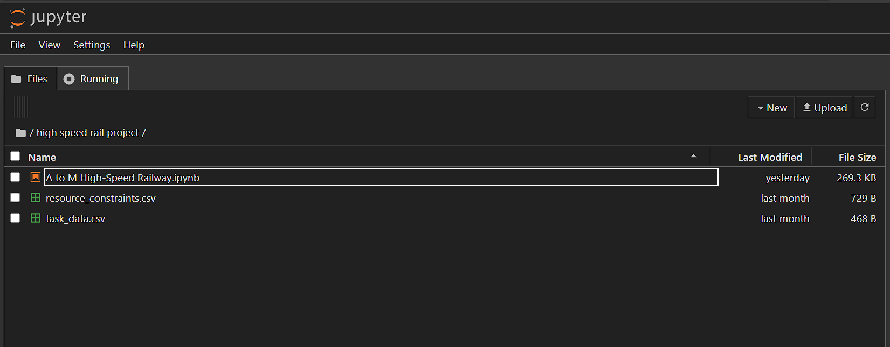

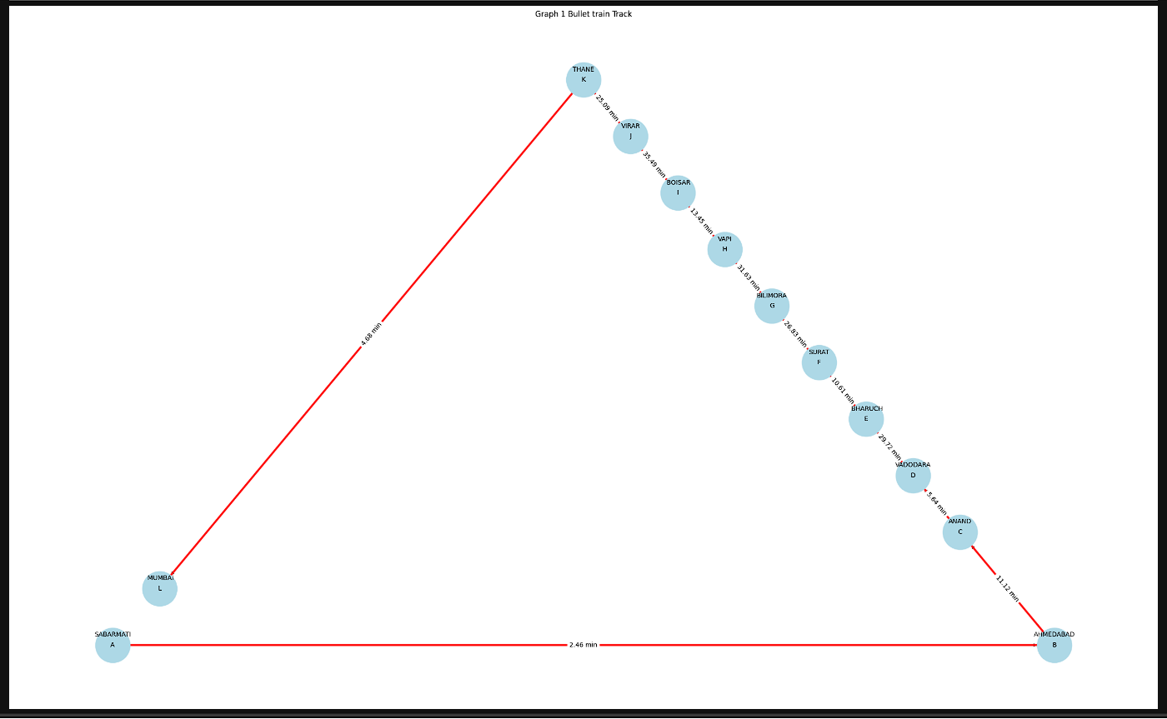
VISUAL OUTPUTS 1

DATA FOR OUTPUT 1

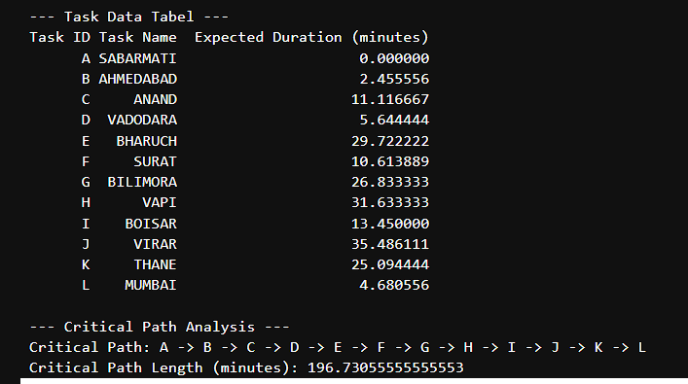

VISUAL OUTPUT 2
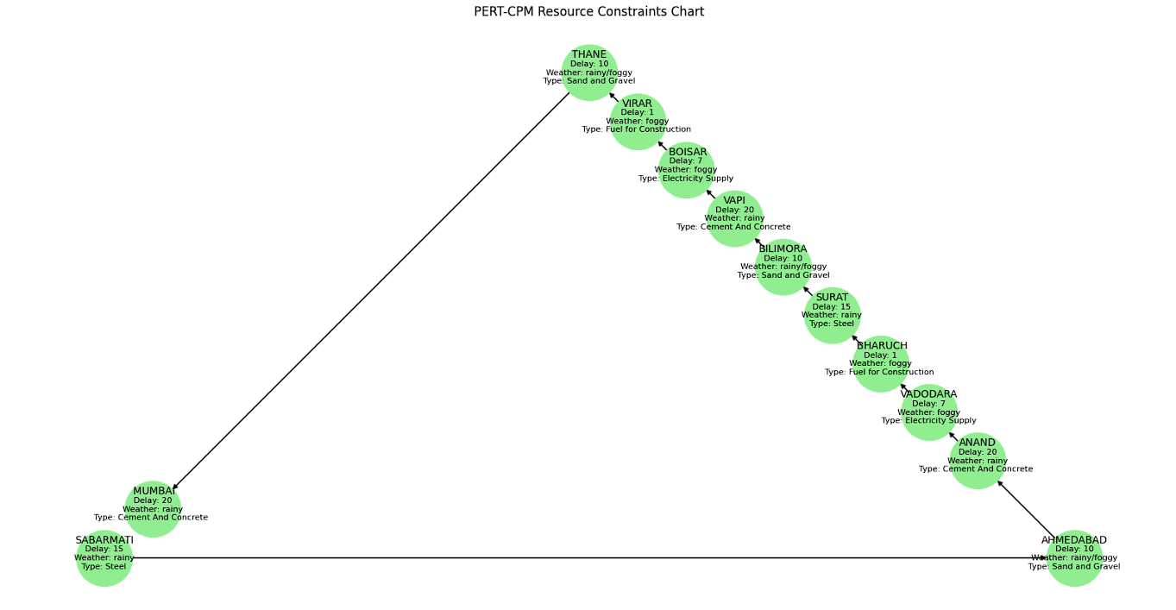

DATA FOR OUTPUT 2

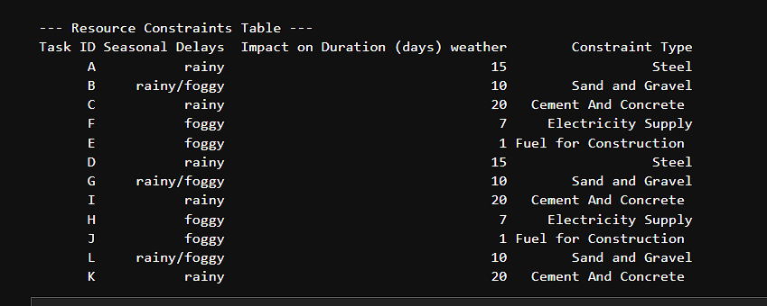

- The Ahmedabad-Mumbai High-Speed Railway Project is a landmark initiative that has the potential to transform India’s transportation infrastructure. Despite significant constraints, including financial limitations, land acquisition challenges, and regulatory hurdles, the project represents a crucial step towards modernization.
CONCLUSION

- The integration of advanced Japanese technology, coupled with its economic and environmental benefits, underscores its long-term significance. While the path to completion may be challenging, the project's success will serve as a model for future high-speed rail networks in India, fostering sustainable development and regional connectivity.

- This project provides a clear, structured approach to analyzing project tasks and constraints, visualizing dependencies, and identifying critical path.
- The graphical representation allows for easy identification of potential bottlenecks or risks in the project timeline due to resource constraints, enabling better decision-making in project planning and management.

REFERENCES
1. Kerzner, H. (2017). Project Management: A Systems Approach to Planning, Scheduling, and Controlling. John Wiley & Sons.
2. Williams, T. (2016). Managing Project Risks and Uncertainty. Wiley-Blackwell.

